**AIDA Marketing Strategy:**

**Football Accessories**

**B2C**

**Attention:**

* **Platform** : Facebook, YouTube, Instagram, Google Ads
* **Demographics** : Young Adults around 15-25 and Males
* **Interest** : Every young adult who wants to play football
* **Content** :

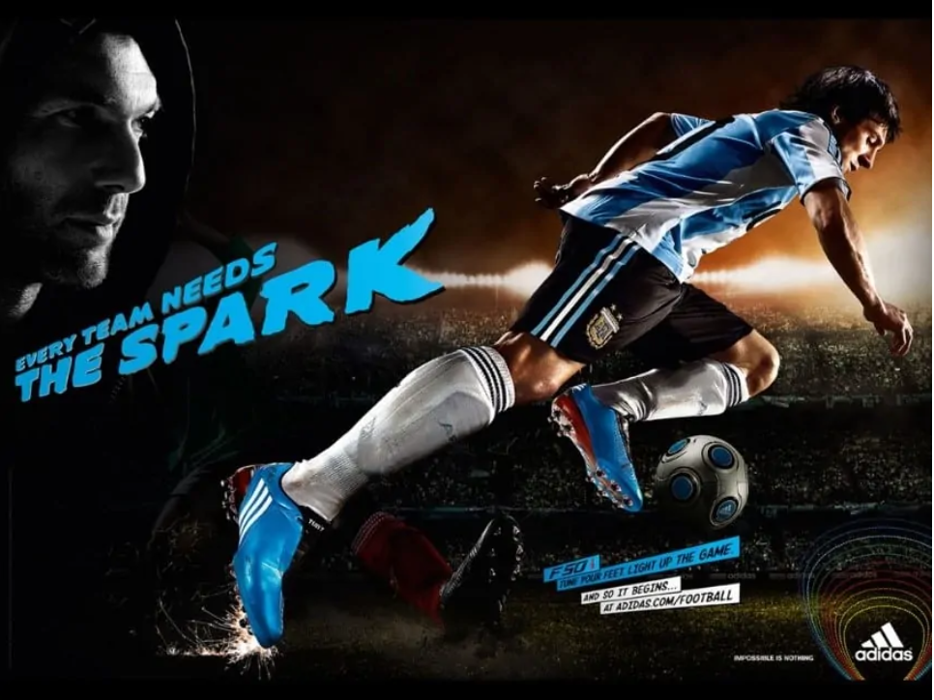

Lionel Messi’s picture initially attracts the consumer, the intended audience being sports (especially football) enthusiasts. The contrasting colours of the shoe and matching caption convey that it’s a shoe advertisement. The shoe appears to be emitting sparks (representing fast performance), and the caption contains the same imagery. So, the consumer gets curious and looks up what exactly does the campaign refer to and how can ‘that spark’ be added to the team. At this point, considerable interest has been generated and the consumer has most likely read up the features of the shoe.

**Interest:**

* **Platform** : Facebook, YouTube, Instagram, Google Ads
* **Demographics** : Young Adults around 15-25 and Males
* **Interest** : Every young adult who wants to play football
* **Content** :

Video link:

By the video link you can see the play of various players it makes the excitement level high of the consumer

<https://youtu.be/eGUor824a74>

**Desire:**

* **Platform** : Facebook, YouTube, Instagram, Google Ads
* **Demographics** : Young Adults around 15-25 and Males
* **Interest** : Every young adult who wants to play football
* **Content** : Give the price range and various coupon codes for the other football accessories

**Desire:**

* **Platform** : Facebook, YouTube, Instagram, Google Ads
* **Demographics** : Young Adults around 15-25 and Males
* **Interest** : Every young adult who wants to play football
* **Content** : Most probably the consumer will buy after seeing all the content i.e image, video, and offers